Title: Involio Auto Mimic Trader – Setup Guide (Tampermonkey + Chrome)
Overview
This guide shows you how to turn Involio Mimic Trades into fully automated Mimic Trades using a Tampermonkey script in Google Chrome. The script can automatically:
- Open new mimic trades
- Modify existing mimic trades
- Close mimic trades when the trader closes
All of this runs directly in the browser, with no API and no AI fees.

1. What you need
- A Windows PC that can run 24/7.
- Google Chrome.
- The Tampermonkey extension for Chrome.
- An Involio account with trade profiles you want to mimic.

2. Install Tampermonkey in Chrome
- Open Chrome.
- Go to the Chrome Web Store and search for “Tampermonkey”.
- Install the Tampermonkey extension.
- Make sure it is enabled (the Tampermonkey icon should appear in the extensions area).

3. Add the Involio Auto Mimic script
- Click the Tampermonkey icon → select “Dashboard”.
- Click “+” (Add a new script).
- Delete any code that appears by default.
- Open the file Invoapp-Auto-Mimic-Trader-19.0-3.js (from the GitHub repo or from your download).
- Copy all of that code and paste it into the Tampermonkey editor.
- Click File → Save (or the save icon).
Expert tip:
After saving the script, press F5 in your Involio Chrome tabs to reload the page and activate the updated script.

4. Open the two required Chrome windows
This setup uses two Chrome windows:
- Window 1 – Notifications
  - URL: https://app.invoapp.com/notifications
  - Purpose: Detects new trades and automatically clicks Mimic Trade.
- Window 2 – Wallet
  - URL: https://app.invoapp.com/wallet
  - Purpose: Handles Trade Updates and Trader Closed events:
    - Copies trader updates to your positions.
    - Closes your copy when the trader closes.
Keep both windows open at all times while the automation is running.

5. Choose which traders to automate
The script acts on the trade profiles you are watching in Involio.
- To automate a trader:
  - Add their trade profile to your watch list in Involio.
- To avoid automating a trader:
  - Do not watch that profile.
Anything on your watch list is treated as “approved for automation”, good or bad.

6. Keep your PC and Chrome awake
Because this is purely browser automation, it only works while:
- Your PC is on and not sleeping.
- Chrome is running.
- The two Involio tabs stay active and not put to sleep by Chrome.
Windows power settings (example):
- Open Settings → System → Power & Sleep.
- Set:
  - Screen: “Turn off after” – your choice (e.g. 2 hours).
  - Sleep: “Never” (when plugged in).
Windows Update active hours:
- Go to Settings → Windows Update → Advanced options.
- Set Active hours to something like 6am – 3am so Windows does not force restarts overnight.
Startup apps:
- Open Task Manager → Startup Apps.
- Disable anything that might trigger reboots or interfere overnight.
Chrome “Memory Saver” / sleeping tabs:
- In Chrome, go to Settings → Performance.
- Under “Always keep these sites active,” add app.invoapp.com.
- This prevents Chrome from putting your Involio tabs to sleep.

7. Adjustable script settings (version 21.7)
All of the settings you should ever touch are grouped near the top of the script file Invoapp-Auto-Mimic-Trader-21_7.js. They appear under a big comment that says “USER SETTINGS – SAFE KNOBS TO EDIT (READ ME FIRST)”.
To change a setting:
- Open the .js file in Notepad.
- Find the setting name.
- Change the number on the right side.
- Save the file and refresh your Involio tabs in Chrome.
- Always test with small size first.

7.1 Position size
- FORCE_POSITION_PCT
  - null = “CAP mode”: follow the trader’s size but cap it.
  - 2.0 (example) = “FIXED mode”: always use 2% of your wallet per trade.
- MAX_POSITION_PCT
  - Used only in CAP mode.
  - Example: 4.0 = never use more than 4% of your wallet on a trade.

7.2 Stop loss
- MANAGE_STOP_LOSS
  - true = script sets stop‑loss price automatically.
  - false = you manage stop losses yourself.
- STOP_LOSS_PCT
  - How far away the stop is from the entry, in percent.
  - Example: 4.0 = 4% stop loss.
- REQUIRE_SL_BEFORE_CONFIRM
  - true = if the script cannot verify the stop‑loss on screen, it will not confirm the trade.
  - false = it will confirm even if verification is not perfect.

7.3 Emergency wallet guard (account‑wide)
- EMERGENCY_WALLET_LOSS_PCT
  - Example: 8.0 = emergency mode if your wallet is down around 8% or more.
- EMERGENCY_MAX_LOSS_USD
  - Example: 10.0 = emergency mode if your wallet is down around $10 or more.
- EMERGENCY_REQUIRES_BOTH
  - true = both percent and dollar limits must be hit to trigger emergency.
  - false = hitting either limit is enough.
- PAUSE_NEW_OPENS_AFTER_EMERGENCY
  - true = after emergency, the script stops opening new trades.
  - false = it continues to open new trades.
- RESUME_WALLET_UPDATES_AFTER_EMERGENCY
  - true = wallet tab keeps watching existing trades so the trader can still close at profit.
- ENABLE_AUDIO_ALERTS
  - true = one‑time beep when emergency triggers (once per browser session).
  - false = no sound.
- ENABLE_EMERGENCY_BANNER
  - true = show a red “LOSS ALERT” banner at the top when in emergency mode.
  - false = no banner.

7.4 Per‑trade dollar stop loss
- ENABLE_DOLLAR_STOP_LOSS
  - true = automatically close any individual trade that hits a dollar loss limit.
  - false = do not auto‑close trades by dollar amount.
- AUTO_CLOSE_USD_THRESHOLD
  - This is your per‑trade dollar stop.
  - Example: 7.5 = if a trade’s loss reaches about −$7.50, the script closes that trade.
  - To change it to $25, edit this line to:
    - const AUTO_CLOSE_USD_THRESHOLD = 25.0;

7.5 Symbol / leverage filters
- SYMBOL_BLACKLIST
  - List of symbols to block.
  - Example: ['DOGE', 'PEPE'] will skip those symbols completely.
- MAX_ALLOWED_LEVERAGE
  - Maximum leverage allowed.
  - Example: 20 = up to 20x.
  - For more safety, set this to 5 or 10.

7.6 Notification age
- MAX_AGE_MINUTES
  - Maximum age of a notification (in minutes) for the script to still act on it.
  - Example: 10 = skip trades older than 10 minutes.

7.7 Advanced timing (normally leave alone)
- These control internal timing and recovery:
  - SCAN_MS, MAX_EXEC_MS, STALE_MS, CONFIRM_WAIT_MS, OPEN_CONFIRM_MS, WRONG_PAGE_MS, POST_ACTION_COOL, RELOAD_MIN_S, RELOAD_MAX_S, MODAL_SETTLE_MS, OPEN_BUTTON_TIMEOUT_MS, CONFIRM_BUTTON_TIMEOUT_MS, VERIFY_SL_ATTEMPTS, VERIFY_SL_INTERVAL_MS, VALUE_VERIFY_ATTEMPTS, VALUE_VERIFY_INTERVAL_MS.
- If you are not a coder, leave these at their defaults.

8. How it behaves in practice
From your perspective:
- On the Notifications tab:
  - When a watched trader posts “opened new trade”, the script:
    - Detects it within a short delay (usually 20–30 seconds).
    - Clicks Mimic Trade automatically.
- On the Wallet tab:
  - For Trade Updates, it:
    - Copies the trader’s updates to your mimic positions (confirming dialogs automatically).
  - For Trader Closed, it:
    - Closes your copy within roughly 30–45 seconds.
You can watch the status badge the script creates in the corner of the page to see what it is doing and view its activity log.

9. Safety, testing, and disclaimers
- Start with small position sizes and low risk until you are confident it behaves as expected.
- Monitor it regularly, especially when Involio changes its UI or adds new features.
- This is experimental automation and can fail, mis‑click, or stop working if the site changes.
- You are fully responsible for how you use it and for any resulting trades, gains, or losses.

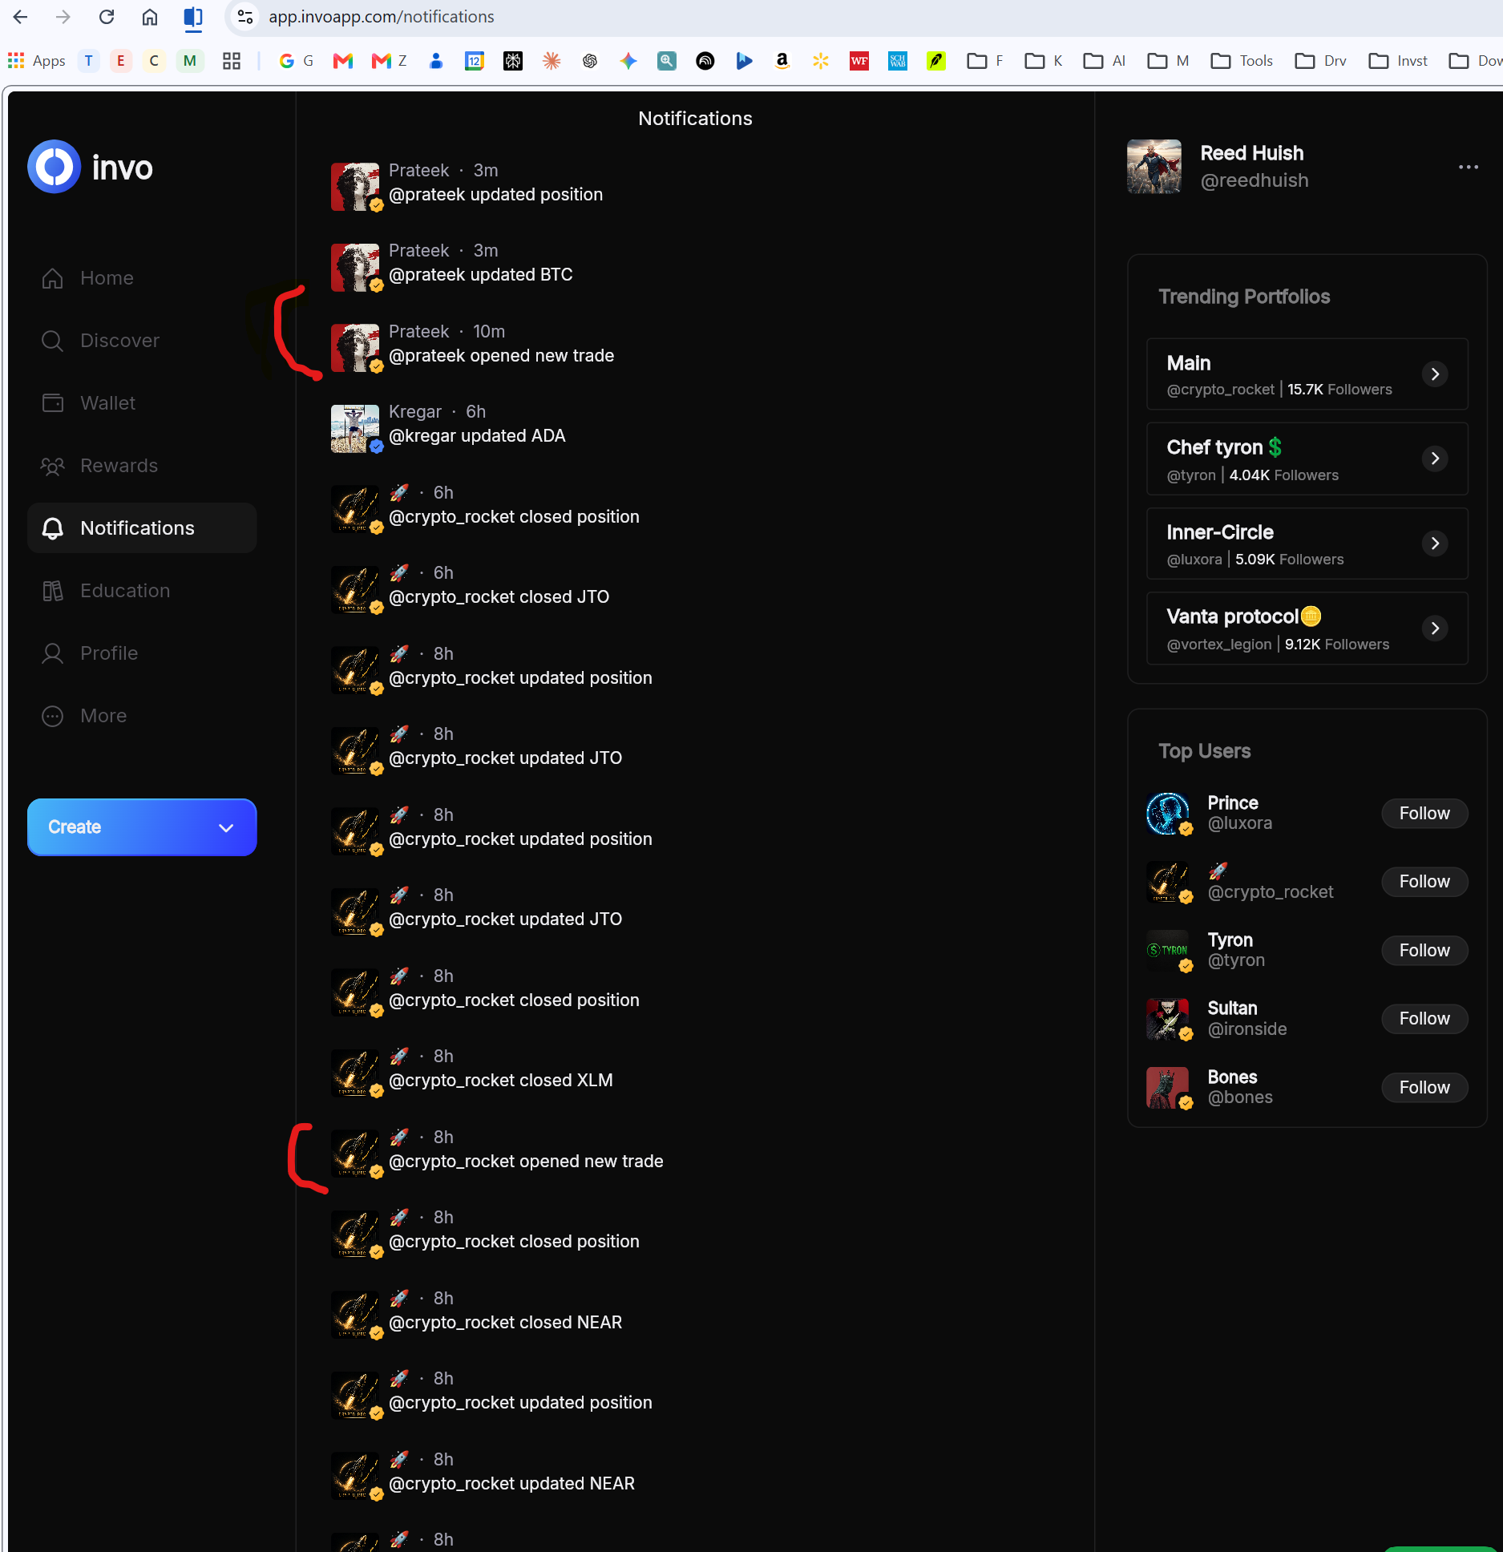

I marked the ones in RED that tampermonkey got the signal and clicked MIMIC (usually within 20-30 seconds of the “opened new trade” being posted)

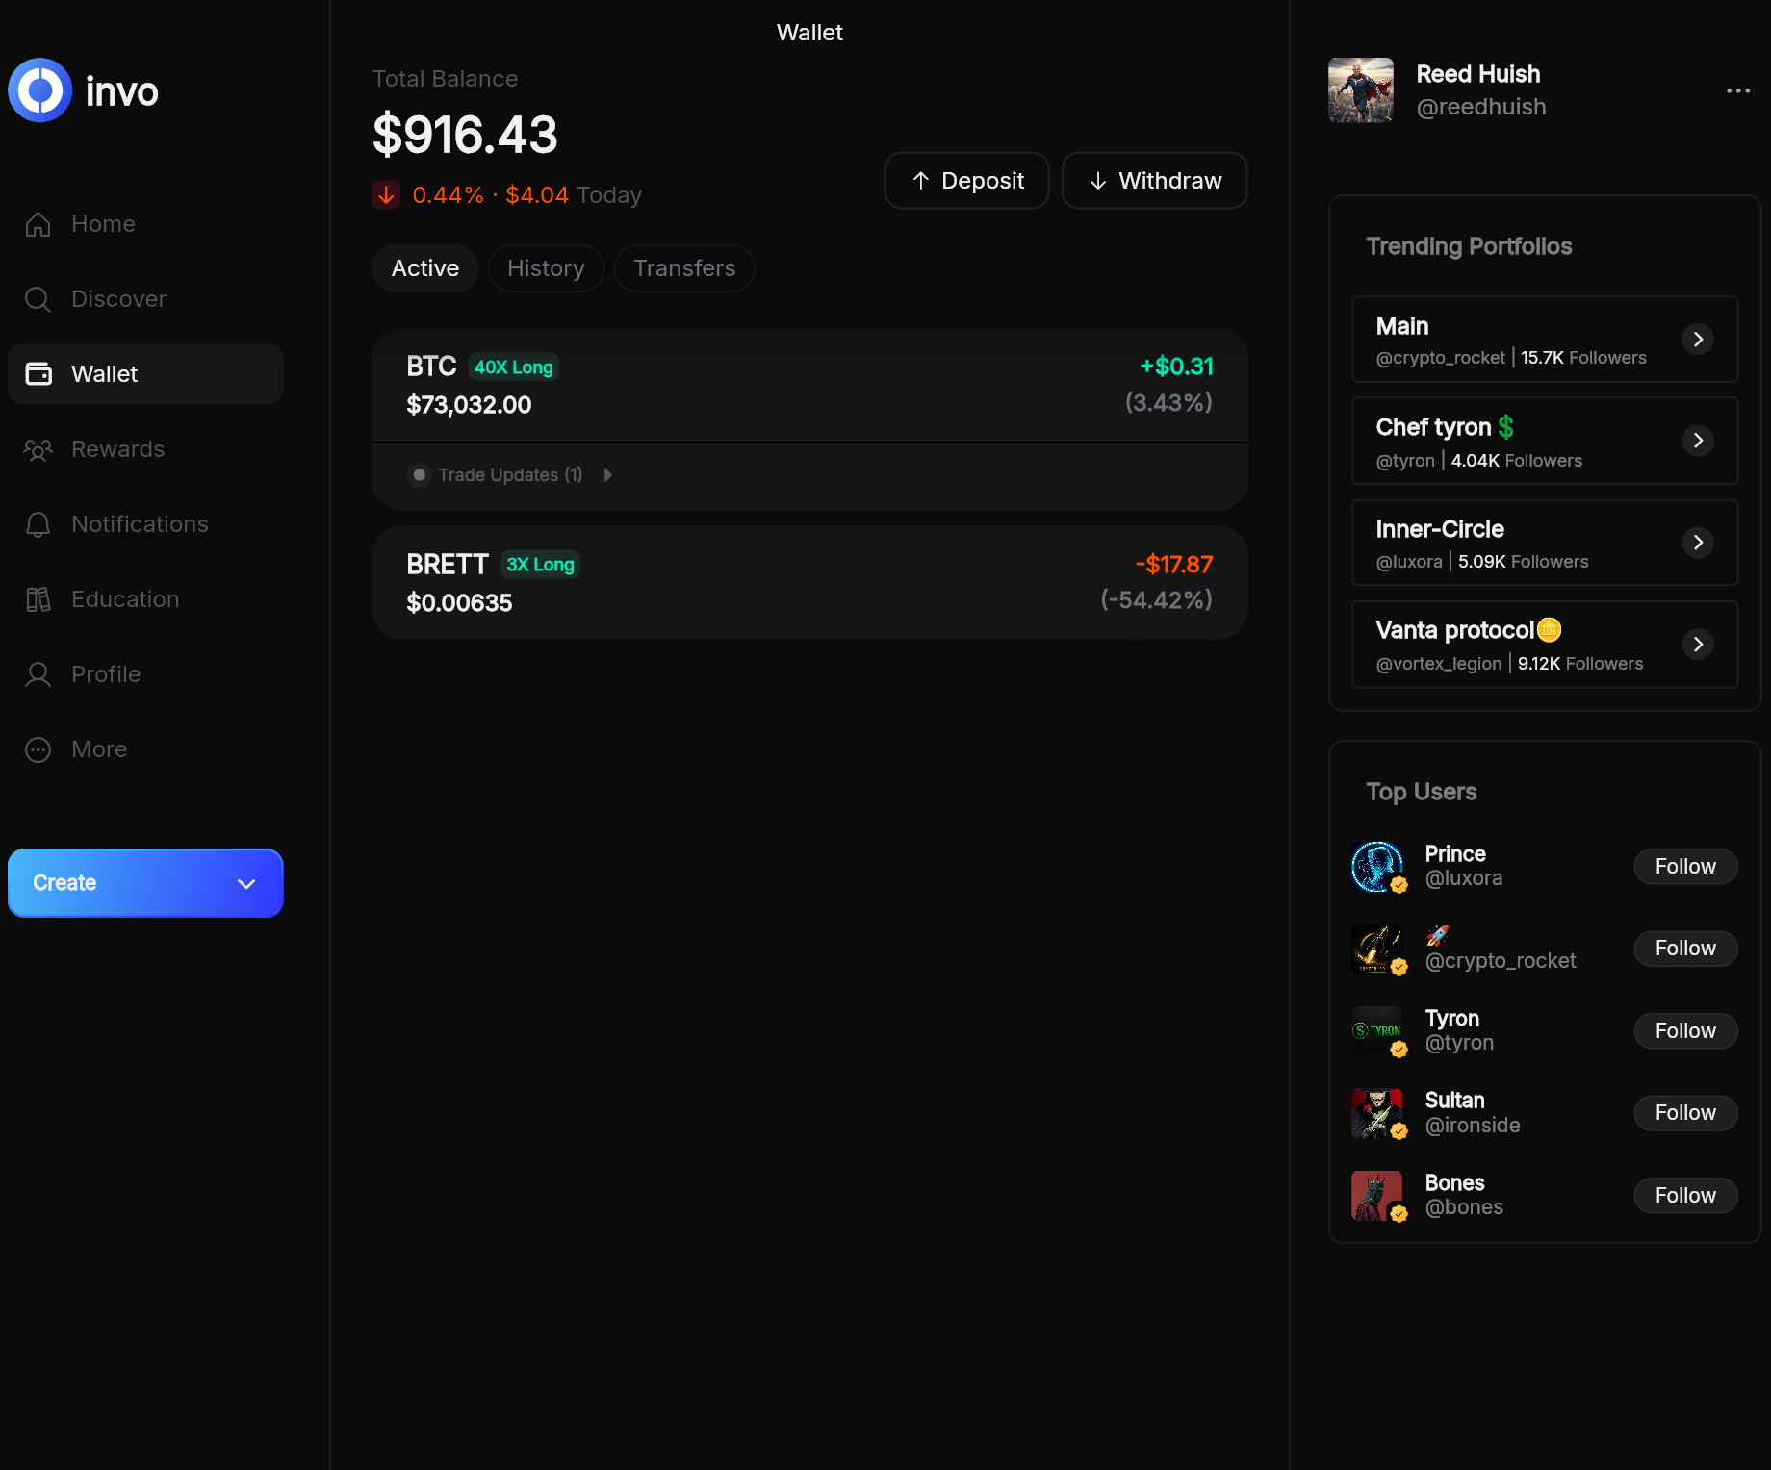
On the wallet page it does ALL the trade updates, including doing a default mimic of all the trader updates to that trade. And when the trader closes the Trade it closes it too. Usually within about 30-45 seconds.

You need to CHOSE YOUR TRADE PROFILES -- add them to your watch list in your Involio account. This will automate the Mimic. It should do everything for you. If you select a Trade Profile you don't want. DO NOT ADD IT to your Invo account (i.e., do not WATCH that trade profile). Good or bad, it will automate it.

I set a stop loss coded at 2%. I'm playing with this right now. Again I used Claude to update the Python script, add this to Claude (I use the free version) and it will understand exactly what is being done. And you can tweak and automate this as you see fit.

